Eating in prison

Workbook 3

Talking about food

Contents page

How to use the workbook 3

Unit 1 Describe the food you eat in prison 5

Unit 2 Read about a cook in prison and
practise present and past simple 8

Unit 3 Learn words to describe how often you do something 13

Unit 4 Talk about amounts of food – much / many 16

Unit 5 Complaining about food 19

Test yourself 21

End of workbook check 24

Answers 25

How to use the workbook

This workbook has activities on
- reading
- writing
- grammar
- vocabulary
You need a pen or pencil.

Do the activities then check your answers using the Answers pages at the back of the workbook.

Sometimes there will be a Glossary for new words. A glossary is a very short dictionary that explains the meanings of new words.

There is sometimes some information to read:

Information
If you see a box like this, read the information carefully. It will help you with the next task.

Sometimes you have to do some work outside your cell:

If you see something in a box like this, it means you have to do something outside your cell. For example, maybe you will have to;
- ask someone a question
- check something with your landing officer
- read something
- find or get something

Eating in Prison Workbook 2 Talking about food in prison

This workbook will help you learn English so that you can talk about food and eating in prison. You will learn new words and practise using verbs.

Learning goals
By the end of this workbook you will be able to:

- use adjectives to describe the food you eat
- write sentences about the food in prison
- know how to use the words ‘much’ and ‘many’
- know when to put ‘-s’ at the end of a verb
- make questions using the past simple
- use the adverbs (sometimes, often, never, etc.) to talk about how often you do something


Unit 1 - Talking about food
Meet Bart. You are going to read about the food he eats in prison.

An adjective is a describing word. It gives you more information about a noun (name of something), for example, my tea is cold.
Cold is an adjective because it tells you about the tea.
We use adjectives to describe lots of things, for example, what someone looks like. My friend is tall. I have brown hair. We can also use adjectives to describe the food we eat.

1.1 Read Bart’s letter to friend and answer the questions.
Hi Dave
How are you? I haven’t got much to write about – just the food. You asked me what it was like in your last letter. Well, not ‘delicious’ like you say! Not good at all!
We get a lot of soup and it’s often cold. Curry is on the menu a lot, but it’s never spicy and doesn’t really have any taste. And there isn’t much meat in it, so I normally go back hungry. We get stew too – but this is disgusting and always really salty. Pudding is nearly always served with custard – and this is like lumpy yellow paint.
I’ve started to eat fruit since I’ve been inside. Never did before! Most of the men just eat chips and pies and put on weight. They come in thin and get out fat. Most of the food here is very fattening.
So, that’s it from me. Write to me soon…..
Bart

Bart

Glossary
stew meat cooked with vegetables in sauce
custard sweet yellow sauce for puddings/desserts

1.2 Find the adjectives. What words does Bart use to describe the food?
- The soup is _________________________
- The curry isn’t very _______________________
- The stew is ___________________________
- The custard is ___________________________
- Most of the food is ________________________
1.3 Match the describing words with their meaning.
- spicy makes you get fat
- disgusting tastes of spices/ hot
- lumpy horrible
- salty great taste
- fattening has too much salt
- delicious not smooth

1.4 Read the letter again and answer the questions.
- What is the problem with the soup?
- Does Bart like the stew?
- What has Bart started to eat in prison?
- What is the most popular food for the men?
- Does Bart think the food is healthy?

1.5 We can use adjectives to talk about food that is nice and food that isn’t nice. Put the adjectives from the letter in the correct column. If you think the word means nice, put it in the positive column. If you think the word means not nice, put it in the negative column.
Positive (nice) | Negative (not nice)
 | e.g. horrible

Can you think of other adjectives you to describe food?
Put them in the box too and ask your teacher to check

1.6 Now choose an adjective to put in these sentences.

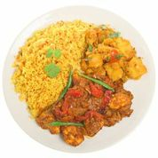
1. Bart put too much salt on his chips, so they were very ...........................
2. Nick’s curry was very ...........................
3. Ali didn’t like the dinner last night it was...........................
4. Gabor left his cup of coffee for 20 minutes so it got.........................
5. Bart liked dinner. It was really nice. It was................................

Unit 2 – The present simple. A day in the life of a prison cook
2.1 Tony is a cook who works in the prison.
Read about his day and then do the exercises on the next page.

Glossary
check make sure something is OK
occasionally sometimes
prepare to get ready
event something that happens – a celebration
to be short of something to not have enough of something

A day in the life of a prison cook
I usually arrive at work at 7am and have a cup of coffee. At 7:15 I check the cupboards and make a note of things we are short of. The prisoners normally arrive at 8:30 am and I give them their jobs for the day. If anyone is unwell I send them back. I never allow a sick person to work in the kitchen.
On Friday and Saturday the hot meal is at lunchtime, but Monday to Thursday, the hot meal is in the evening and there are sandwiches at lunchtime. Monday to Thursday I prepare the meat and fish for dinner at about 9am, and about 11am I prepare the vegetables. Occasionally I will help the prisoners make a cake if the prison needs one for an event. I usually have lunch at 12:00.
At 12:15 the prisoners arrive and we serve lunch or sandwiches. I always check that the prisoners have tidied up and then they return to the wings.
At 2 pm, I usually go through the menus for the next day. After that I sometimes look at menu sheets with the manager, or I order things we need. At about 3 pm I take food out the freezers and put it in the fridge ready for the next day.
I normally go home at about 4 pm

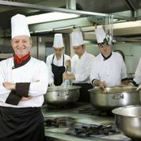
2.2 What does Tony do at these times? Write sentences.

7:15 am 8:30 am 9 am
12:00 3 pm 4 pm

- 8.30

___________________________________________________________________________________________________________________________________________________________________________________________________________________________________________________________________________________________________________________________________________________________________________________________________________________________________________________________________________________________________________________________________________________________________________________________________________________________________________________________________________________________________________________________
Check your answers

2.3 The past simple Read about what five people eat in a day in prison. Is it similar to your food?
name | breakfast | lunch | dinner
  Bart | roll with jam  tea | cheese and crackers  apple | chicken curry  ice lolly
  Jak | bran flakes with milk  coffee | tuna and sweetcorn sandwich  crisps  orange | cauliflower cheese  peas  fruit
Anita   | roll with jam  coffee | egg mayo sandwich  crisps  orange | halal cottage pie  peas  raspberry ripple mousse
Nick   | cornflakes with milk  tea | egg and tomato sandwich  crisps | pork pie salad  mash potato  chocolate muffin
Ali   | roll with jam  coffee | 2 boiled eggs with bread and margarine  crisps  apple | halal chicken and sweetcorn pie  mixed vegetables  new potatoes  apple crumble

2.4 Questions with the past simple







Making questions about the past – (past simple)
Look at the two questions. Which one is correct? Check your answer.
What did Bart have for lunch? What did Bart had for lunch?

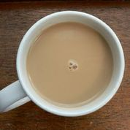
2.5 Now put these questions in order and answer them.
For example: have breakfast? for did Ali What
What did Ali have for breakfast?
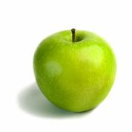
1. Jak What after have did cauliflower cheese and peas?
……………………………………………………………
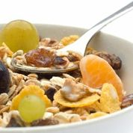
2. have did drink Bart with What a roll and jam?
…………………………………………………………….
3. have Nick did for What breakfast?
……………………………………………………………………
4. fruit did What have Anita lunch? for have
………………………………………………………………………….

2.6 Write using the past simple
Write some sentences about what you ate yesterday. Say what you had for breakfast, lunch or supper
Start your sentences; For breakfast I had........
__________________________________________________________________________________________________________________________________________________________________________________________________________________________________________________________________________________________________________________________________________________________________________________________________________________________________________________________________________________________________________________________________________________________________________________________________________________________________________________________________________________________________________________________________________________________________________________________________________________________________________________________________________________________

Unit 3 How many times/ How often do you do something?
Adverbs of frequency
occasionally for things we don’t do very often
sometimes for things we don’t do all the time
usually and normally for things we do most days
always for things we do all the time
never for things we don’t do


3.1 Read about Tony the cook again in unit 2.
- List three things that Tony usually does?

- What does Tony never do?

- What does Tony sometimes do?

- What does Tony occasionally do?

3.2 Match a phrase from the left to make a sentence about the pictures so that it’s true for you. Write your sentences in the box.


I sometimes eat cereal in the evening

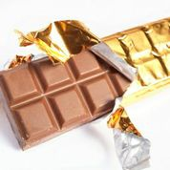
I always eat chocolate in the morning
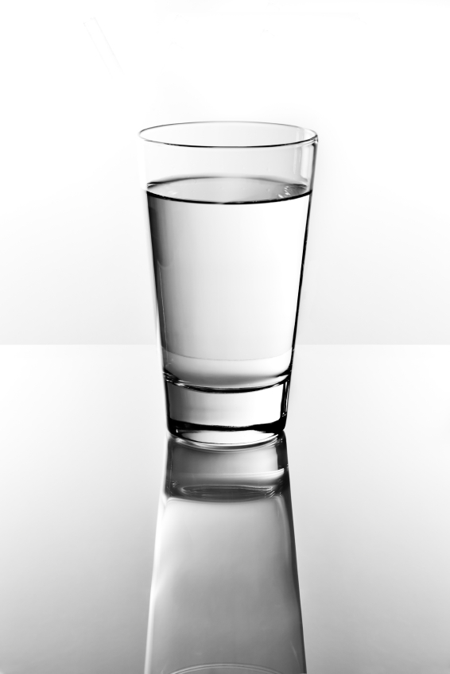
I never eat water for dinner
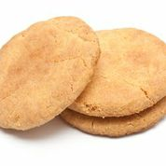
I usually eat biscuits for breakfast
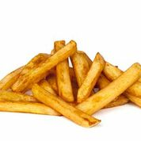
I occasionally drink chips at break time
Write your sentences here.
_____________________________________________________________________________________________________________________________________________________________________________________________________________________________________________________________________________________________________________________________________________________________________________

3.3 Put the adjectives in the sentences below
sometimes usually always never


1. Bart doesn’t like sandwiches.

He ______________has a sandwich for lunch.


2. Jak has cornflakes and milk every day for breakfast.

Jak ______ He __________has cornflakes and milk for breakfast.


3. On most days, Anita has a cup of coffee with her breakfast.
Anita _____________has a cup of coffee with her breakfast.


4. Nick is tired when he gets back to his cell. If he has time, he
has a cup of tea.
Nick ______________________has a cup of tea after work.

5. Ali is a Muslim and only eats halal meat.
Ali _______________ eats halal meat.

Unit 4 Talking about amounts: much / many
Information
We use much when we talk about uncountable nouns.
We use many when we talk about countable nouns.
Look at the explanation below ↓ if you want to understand more about the difference between countable and uncountable nouns.
We usually use much + noun or many + nouns in questions (?), or negative (not) sentences or after the words too and
.
For example, I have too much work. I don’t have many books.

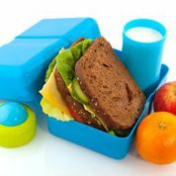
There isn’t much cheese in this sandwich
Cheese is uncountable. You can’t say: 1 cheese, 2 cheese, 14 cheese because you can’t count cheese. This means it is uncountable. There is no plural.

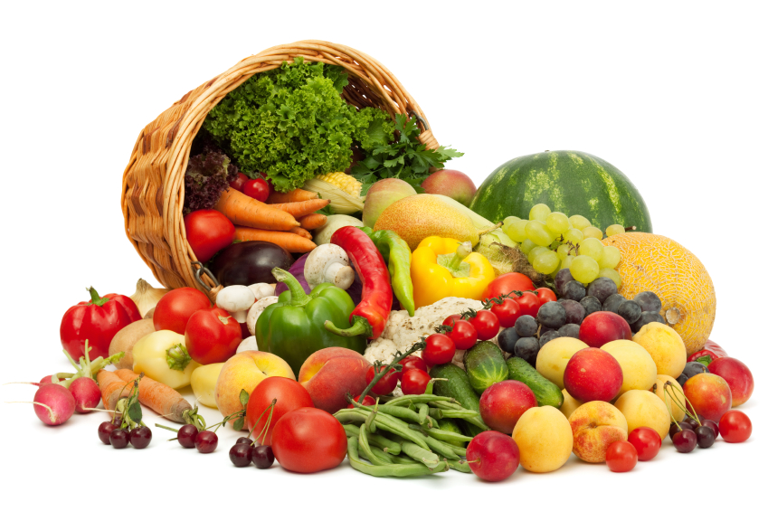
There aren’t many apples in the basket.

You can count apples: for example 1 apple, 2 apples, 14 apples. This means they are countable.
We can add an s to make the plural.

4.1 Choose the correct word.

1. I was late to dinner this evening, so there wasn’t many food / much food for me.
2. How many / much coffee do you have?
3. I didn’t order much / many things from the canteen this week.
4. I don’t want many / much peas thank you.
5. He doesn’t have many / much sugar in his tea.
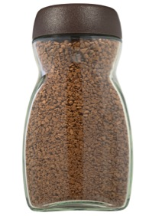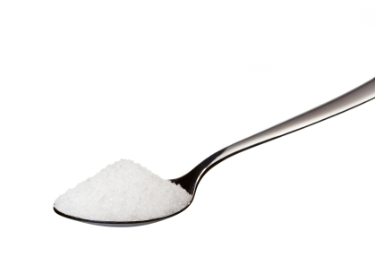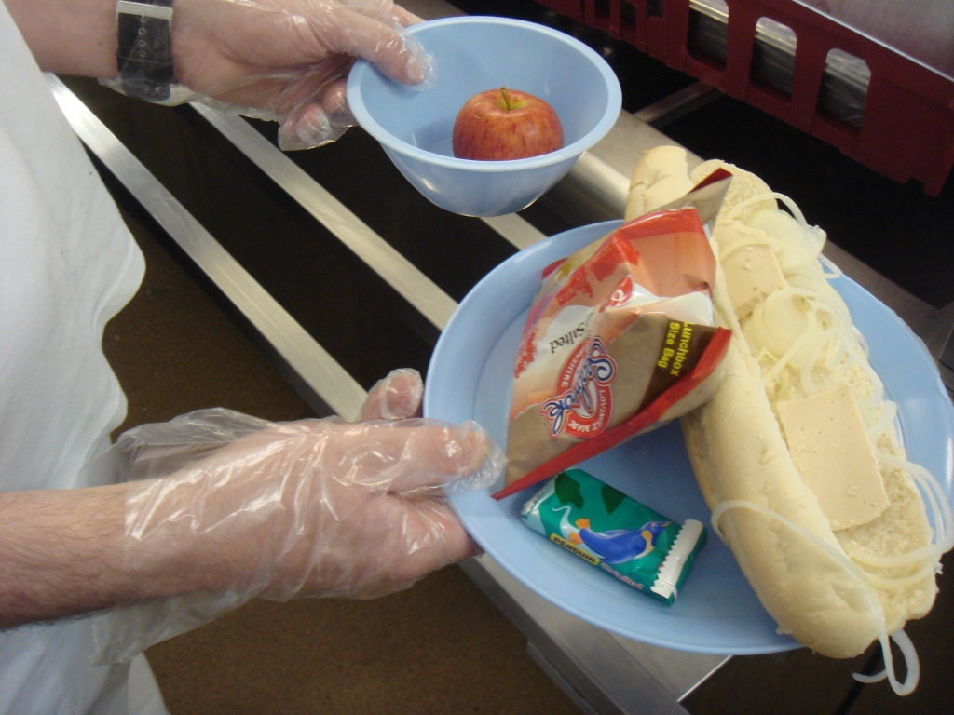

4.2 All about you

Use how much or how many to make questions. Can you answer them?
How much |  | water should you drink every day?
 |  | servings of fruit and vegetables should you have a day?
 |  | calories a day is healthy for a man?
 |  | calories a day is healthy for a woman?
All about you
 |  |  | cups of coffee do you have every day?
 |  |  | cigarettes do you smoke every day?
 |  |  | sugar do you have in your tea/coffee?
 |  |  | time do you spend in the gym?
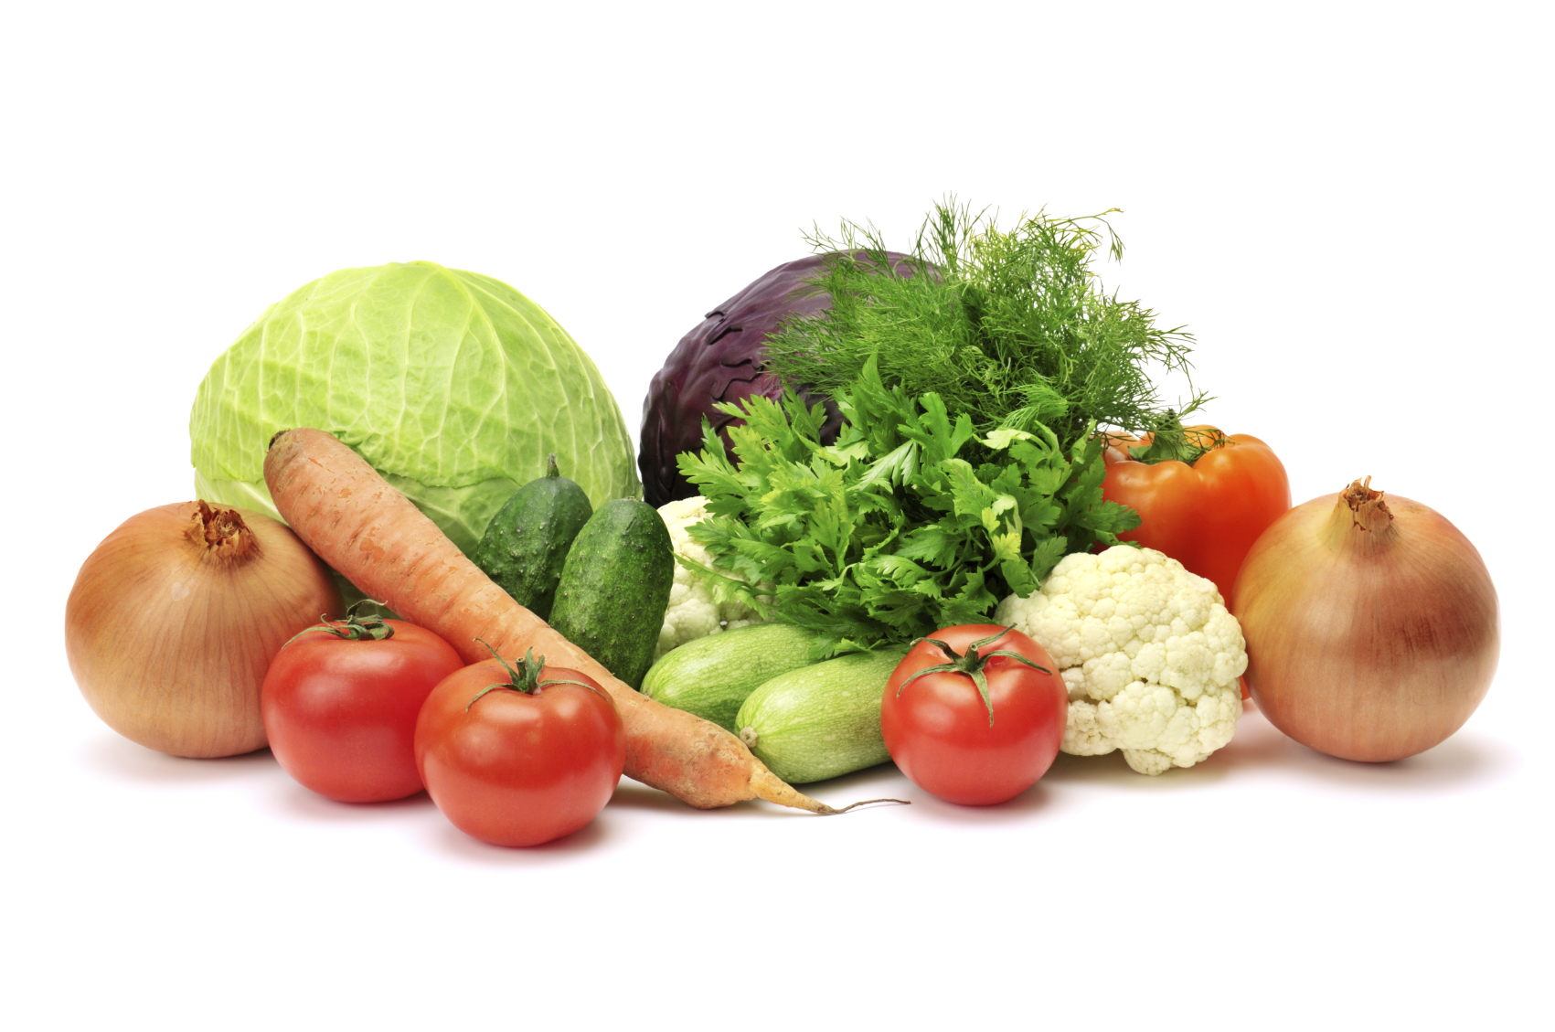 | 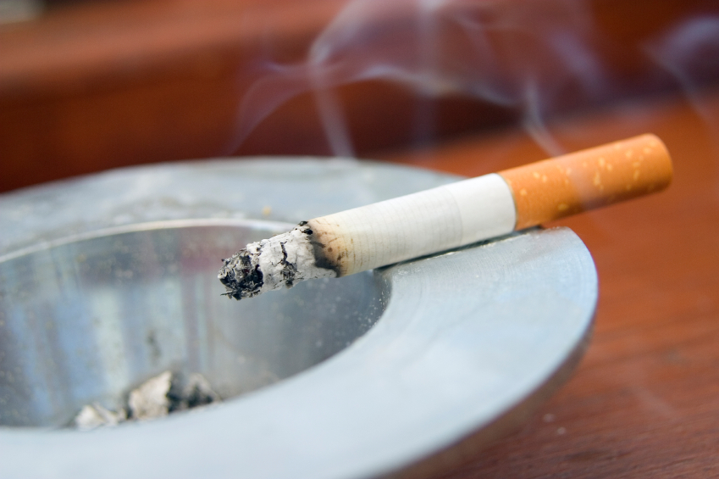 |  |  | 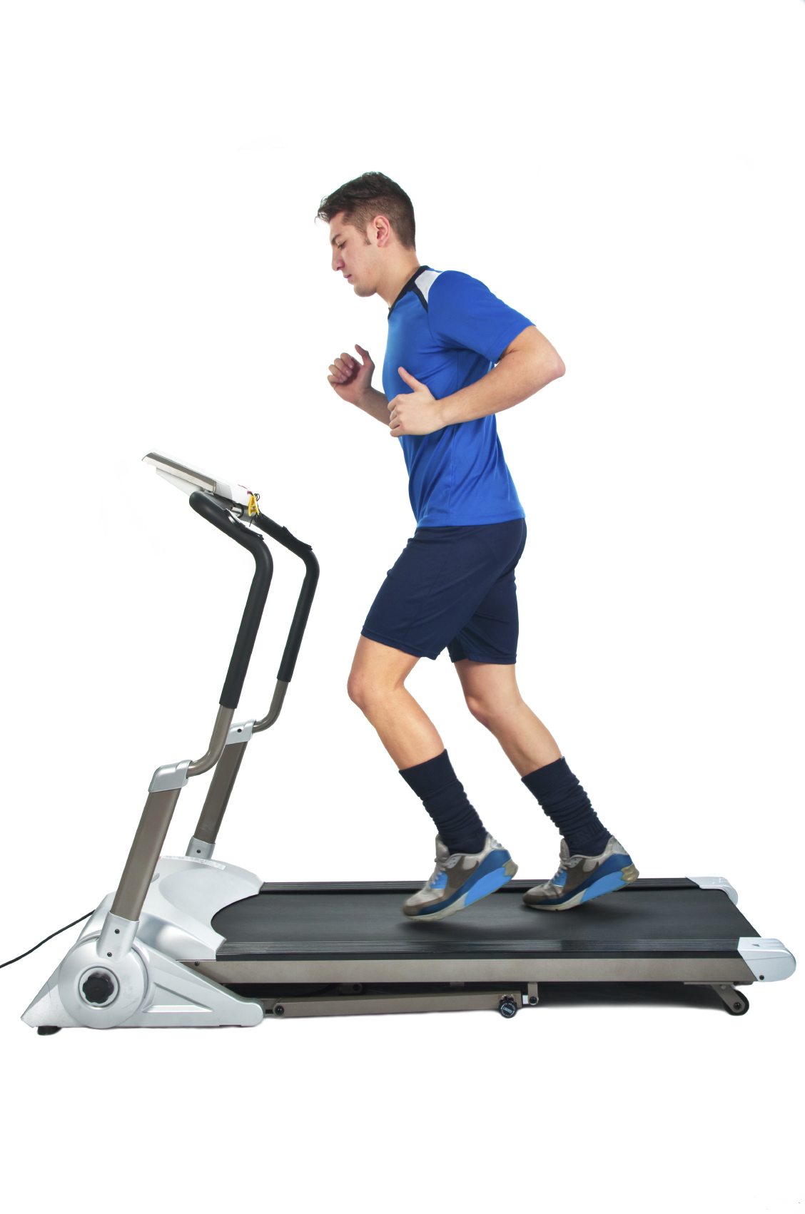 | 

Unit 5 Complaining about food
Kenny has written a letter about prison food. to the prison newspaper insidetime
5.1 Read it quickly (in one minute only!) and answer the questions:
1. Kenny works in the kitchen. True / False
2. He thinks the food is good. True / False
The following is adapted from a letter to insidetime in June 2011

Lies about the food at HMP Hilltop
From K – HMP Hilltop
I have worked in the kitchen here for two-and-a-half years and I can honestly say that the food here is really poor. The main diet consists of prison-made pies and cheap burgers and sausages. Curries and other dishes, such as stews, have had the meat content cut and more veg put into them.
I often see people on the wing scraping their meal into the bin as they go to their cells to eat some canteen-bought noodles. The food ingredients that are bought in by the kitchen are okay, but it’s what they do to it here that makes the food inedible. I’m not a fantastic chef, but the civvy staff and the catering workers really can’t cook at all!

5.2 Now read the letter again and find the words that mean:
bad
didn’t cost lots of money
to take out
so bad you can’t eat it
staff who are not prisoners

* to complain is to say you don’t like something or say something is bad

5.3 Answer the questions

1. How long has Kenny worked in the kitchen there?

2. Write down the names of two things that are often on the menu?

3. What is the main thing in the curries and the stews?

4. What do a lot of people do with their food?

5. What do most people like eating?

5.4 Look at these sentences from another letter complaining about food. Can you put the adjectives in the correct places?

salty inedible poor lumpy cheap
spicy delicious

1. Why are the chips always so ………… ? I need to drink a litre of water with them!

2. The curry is so …………. that it is ………………. No-one can eat it!

3. The custard is very …………….. but it is surprisingly ……………. .

4. The stews are made with …………...meat so the taste is ………………. .
Test yourself! How much can you remember from the workbook?

1. Can you remember the adjectives from the workbook in the crossword?
 |  |  |  |  | 1
 |  |  | 2 |  |  |  |  |  |  |  | 3
 |  |  |  |  |  |  | 4 |  |  | 5
 |  |  |  |  | 6
 | 7
 |  |  |  |  |  |  | 8 |  |  | 9
Across  2. We say this when the food tastes great.  5. A word prisoners use to describe staff who do not wear a uniform, like teachers.  7. Adjective that means the food makes you put on weight.  8. When food has big bits in it. |  |  |  |  |  |  |  |  |  |  |  |  | Down  1. When there is too much salt in a meal.  2. We use this word to describe food that tastes absolutely horrible.  3. The food has the strong flavour of spices; sometimes it is hot like curry.  4. The food is so bad that you can’t eat it.  6. Does not cost very much money.  9. Another word for bad and it also means you don’t have any money.

2. Spelling. Put in the missing letters to spell the adjectives from the workbook.
s _ i _ y  h o _ _ _ _ _ e  l _ _ _ y  s _ _ _ y  f _ t t _ _ _ _ g | d _ _ _ _ _ _ _ u s  d _ _ _ _ _ _ i n g  i n _ _ _ _ l e  p _ _ _  c h _ _ p

3. Use much or many to make questions or sentences.
1. I don’t eat _________ red meat.
2. The dentist says that I eat too ________ sweets.
3. How __________ cooks work in the kitchen?
4. I’ve got too _________ rice on my plate.

4. Can you think of adjectives to describe this food and drink? Ask a teacher, friend or neighbour what words they would use.
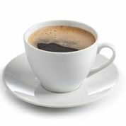
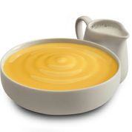


The custard is.........
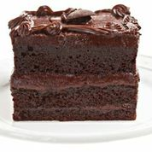

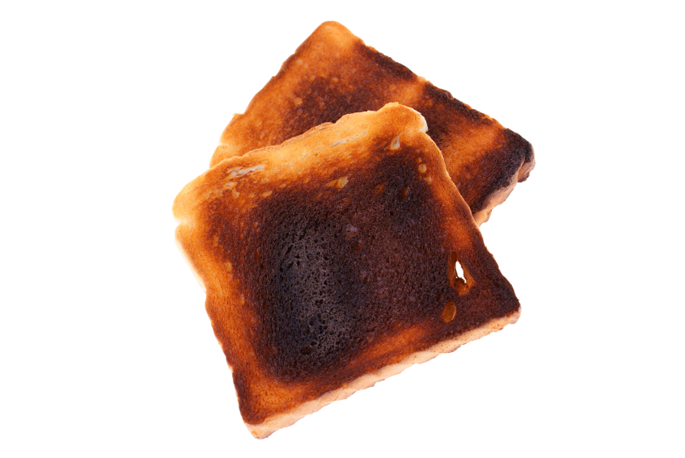
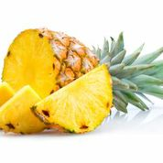

Things I can do

Put I can do this!

Put ? I want more practice

I can | ?
Use adjectives to describe food
Use sometimes/usually/always/never in a sentence
Know when to use much or many
Use the past simple
Write about what I ate yesterday

Answers
Unit 1

1.2 Find the adjectives
- The soup is cold.
- The curry isn’t very spicy.
- The stew is salty and disgusting.
- The custard is lumpy.
- Most of the food is fattening.
1.3 Match the describing words
- spicy tastes of spices/ hot
- disgusting horrible
- lumpy not smooth
- salty too much salt
- fattening makes you get fat
- delicious great taste

- It’s cold
- No (he says it’s disgusting)
- Fruit
- Pies and chips
- No (he says it’s fattening)

1.5 Nice or not nice
Positive (nice) | Negative (not nice)
hot  delicious  spicy (if you like spices!)  other words could be: sweet, juicy | horrible  salty  cold  disgusting  lumpy  spicy (if you don’t like spices!)  cheap  fattening

1.6 Choose an adjective to put in the sentences
- salty
- hot or spicy
- horrible
- cold
- delicious

Unit 2 – Day in the life of a prison cook

2.2
- At 7:15 he checks the cupboards.
- At 8:30 he gives the prisoners their jobs.
- At 9:00 he prepares the meat and fish.
- At 12:00 he has lunch.
- At 3 pm he takes the food out the freezers.
- At 4 pm he goes home.

2.4 Past simple

What did Bart have for lunch? Is the correct question. We use did + infinitive of the main verb.

2.5 Put the questions in order.

- What did Jak have after cauliflower cheese and peas? fruit
- What drink did Bart have with a roll and jam? tea
- What did Nick have for breakfast? cornflakes with milk, and tea
- What fruit did Anita have for lunch? an orange

2.6 Using the past simple

Your writing might look like this.

I had breakfast in my cell at 7:15. I worked in the morning and I had a break at 10:30. Lunch was at 12:00. In the afternoon I had a cup of tea at 3pm. I worked until 4:30 when I went back to my cell. Dinner was in the evening at about 5:30pm. I made a cup of tea in my cell in the evening and ate some biscuits.

Unit 3

3.1 Things Tony usually does

- He usually arrives at work at 7am.
- He usually has lunch at 12:00.
- He usually goes through the menus.
- Tony never allows a sick person to work in the kitchen.
- Tony sometimes looks at menu sheets with the manager.
- Tony occasionally helps the prisoners make a cake.

3.2 Match phrases to make sentences about you
- I always eat cereal in the morning/for breakfast Or
- I always eat biscuits in the morning/in the evening
- I never eat biscuits for breakfast/for dinner or:
- I never eat chocolate for breakfast/for dinner or
- I never eat chips in the morning/for breakfast
- I usually eat chips for dinner
- I usually eat cereal for breakfast
- I usually eat chocolate in the evening
Your writing might look like this
I usually have a cup of tea with my breakfast. I sometimes have a cup of coffee in the morning. I never eat chips for lunch. I usually drink water with my lunch. I occasionally eat chocolate in the evening. I always have a hot chocolate in the evening.

3.3 Put the adverbs in the sentences
- never
- always
- usually/normally
- sometimes
- always

Unit 4 – Using much / many

4.1 Choose the correct word

- I was late to dinner this evening, so there wasn’t much food for me.
- How much coffee do you have?
- I didn’t order many things from the canteen this week.
- I don’t want many peas thank you.
- He doesn’t have much sugar in his tea.

4.2 Use how much or how many to make questions

How much | water should you drink every day?
How many | servings of fruit and vegetables should you have a day?
How many | calories a day is healthy for a man?
How many | calories a day is healthy for a woman?
How many |  | cups of coffee do you have every day?
How many |  | cigarettes do you smoke every day?
How much |  | sugar do you have in your tea/coffee?
How much |  | time do you spend in the gym?
If you drink more than 4 cups of coffee a day, smoke, put lots of sugar in your tea/coffee and don’t go to the gym you are NOT healthy!
If you have 2-3 cups of coffee a day, don’t smoke, don’t have sugar in your coffee/tea and go to the gym, you are doing well!

Unit 5

5.1 Complaining about food
1. Kenny works in the kitchen. True
2. He thinks the food is good. False

5.2 Find words that mean the same
bad | poor
didn’t cost lots of money | cheap
to take out | cut
so bad you can’t eat it | inedible
staff who are not prisoners | civvy (short for ‘civilian’ and pronounced ‘sivvy’)

5.3 Answer questions about Kenny
1. Two and a half years
2. You could say pies, burgers or sausages.
3. Vegetables (veg is short for vegetable)
4. Throw it away/ put it in the bin
5. Noodles that they buy from the canteen sheet

5.4 Put the adjectives in the correct places

1. salty
2. hot / inedible
3. lumpy / delicious
4. cheap / poor

Test yourself! Answers!
1. Crossword
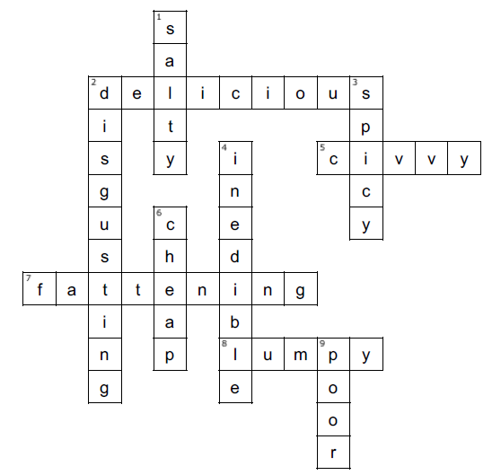
2. Put in the missing letters to spell the adjectives from the workbook.
spicy  horrible  lovely  salty  fattening | delicious  disgusting  inedible  poor  cheap
3. Use much or many to make questions or sentences.
1. I don’t eat much red meat.
2. The dentist says that I eat too many sweets.
3. How many cooks work in the kitchen?
4. I’ve got too much rice on my plate.

